


Nantwich
,
Reaseheath College

Centre Handbook

2026

Contents

Contents ..................................................................................................................................................................... 2
Summary .................................................................................................................................................................... 3
The Centre .................................................................................................................................................................. 4
Location ...................................................................................................................................................................... 5
Airport Transfers: ........................................................................................................................................................................................... 5
Campus Map …..……………………………………………………………………………………………………………………………………………………….6
Local Amenities ......................................................................................................................................................... 7
Accommodation ........................................................................................................................................................ 9
Room Allocation ............................................................................................................................................................................................ 9
Housekeeping ................................................................................................................................................................................................ 9
Key Loss ............................................................................................................................................................................................................ 9
Deposits ............................................................................................................................................................................................................ 9
Meals ........................................................................................................................................................................ 10
Meal times .................................................................................................................................................................................................... 10
Reaseheath College, Nantwich - Sample Menu ............................................................................................................................. 11
Technology ............................................................................................................................................................... 12
Security ..................................................................................................................................................................... 12
Safety ........................................................................................................................................................................ 12
Teaching ................................................................................................................................................................... 13
Placement tests ........................................................................................................................................................................................... 13
Programme .............................................................................................................................................................. 14
A typical day for students ...................................................................................................................................... 15
Reaseheath College, Nantwich Sample Programme - Summer 2026 ............................................................... 16
Facilities .................................................................................................................................................................... 17
Evening entertainment ........................................................................................................................................... 17

Thank you very much for your interest in our centre at Reaseheath College. We hope you find everything you need in the following pages but if you have any questions or specific requests then please get in touch with us at Head Office on 0044 1244 577995.

The contents of this handbook are updated regularly. The latest version will be sent before your arrival.

We look forward to a successful summer 2026 at Reaseheath College.

Summary

College
Intensive English
Performing Arts
Short Transfers

The Centre

Reaseheath College is an agricultural college set amidst stunning parklands, woodlands and farms. It has its own Equine Centre, a beautiful lake and an impressive mid-18th century main building at the heart of the campus.
Despite the rural setting, the campus is located just under 1.5 miles from the town of Nantwich.

It is a closed site with high security and CCTV on campus. All the houses have swipe cards for access. There are wardens who are on-site 24 hours a day.

Around the campus there are grass areas where students can take part in sports and activities.

Reaseheath is a cashless site. If you are unable to travel with a personal debit or credit card, preloaded cards will be available to buy from the UKLC Team.

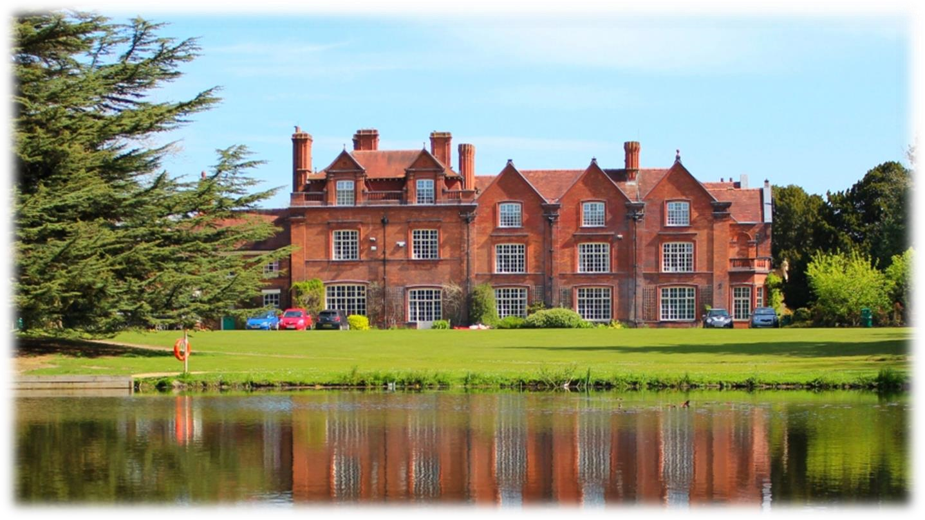

Location

REASEHEATH COLLEGE, NR CHESTER, CW5 6DF

Telephone Number: 01270 625131

Population - 18,734

Reaseheath College is located approximately – 1.4 miles (30 minutes’ walk) from the town centre of Nantwich.

Nantwich is a Roman town and has the largest collection of historic buildings in the county of Cheshire, outside Chester.

Situated on the banks of the River Weaver, Nantwich is famous for the medieval timbered buildings dotted around the town. Stroll through the atmospheric streets and visit for bijou boutiques, antiques dealers and contemporary craft shops.

Chester is the closest city to Nantwich which is just over 20 miles away.

Airport Transfers:
Manchester: 45 minutes
Liverpool: 1 hour
London Heathrow: 3 hours

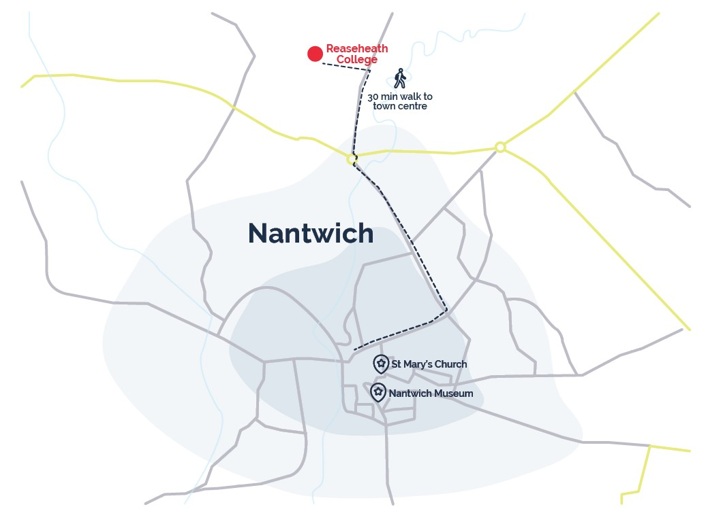
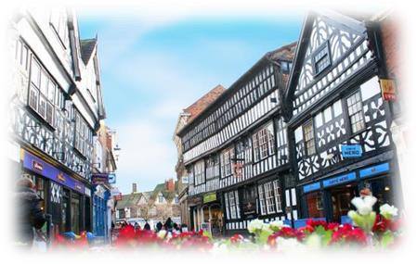

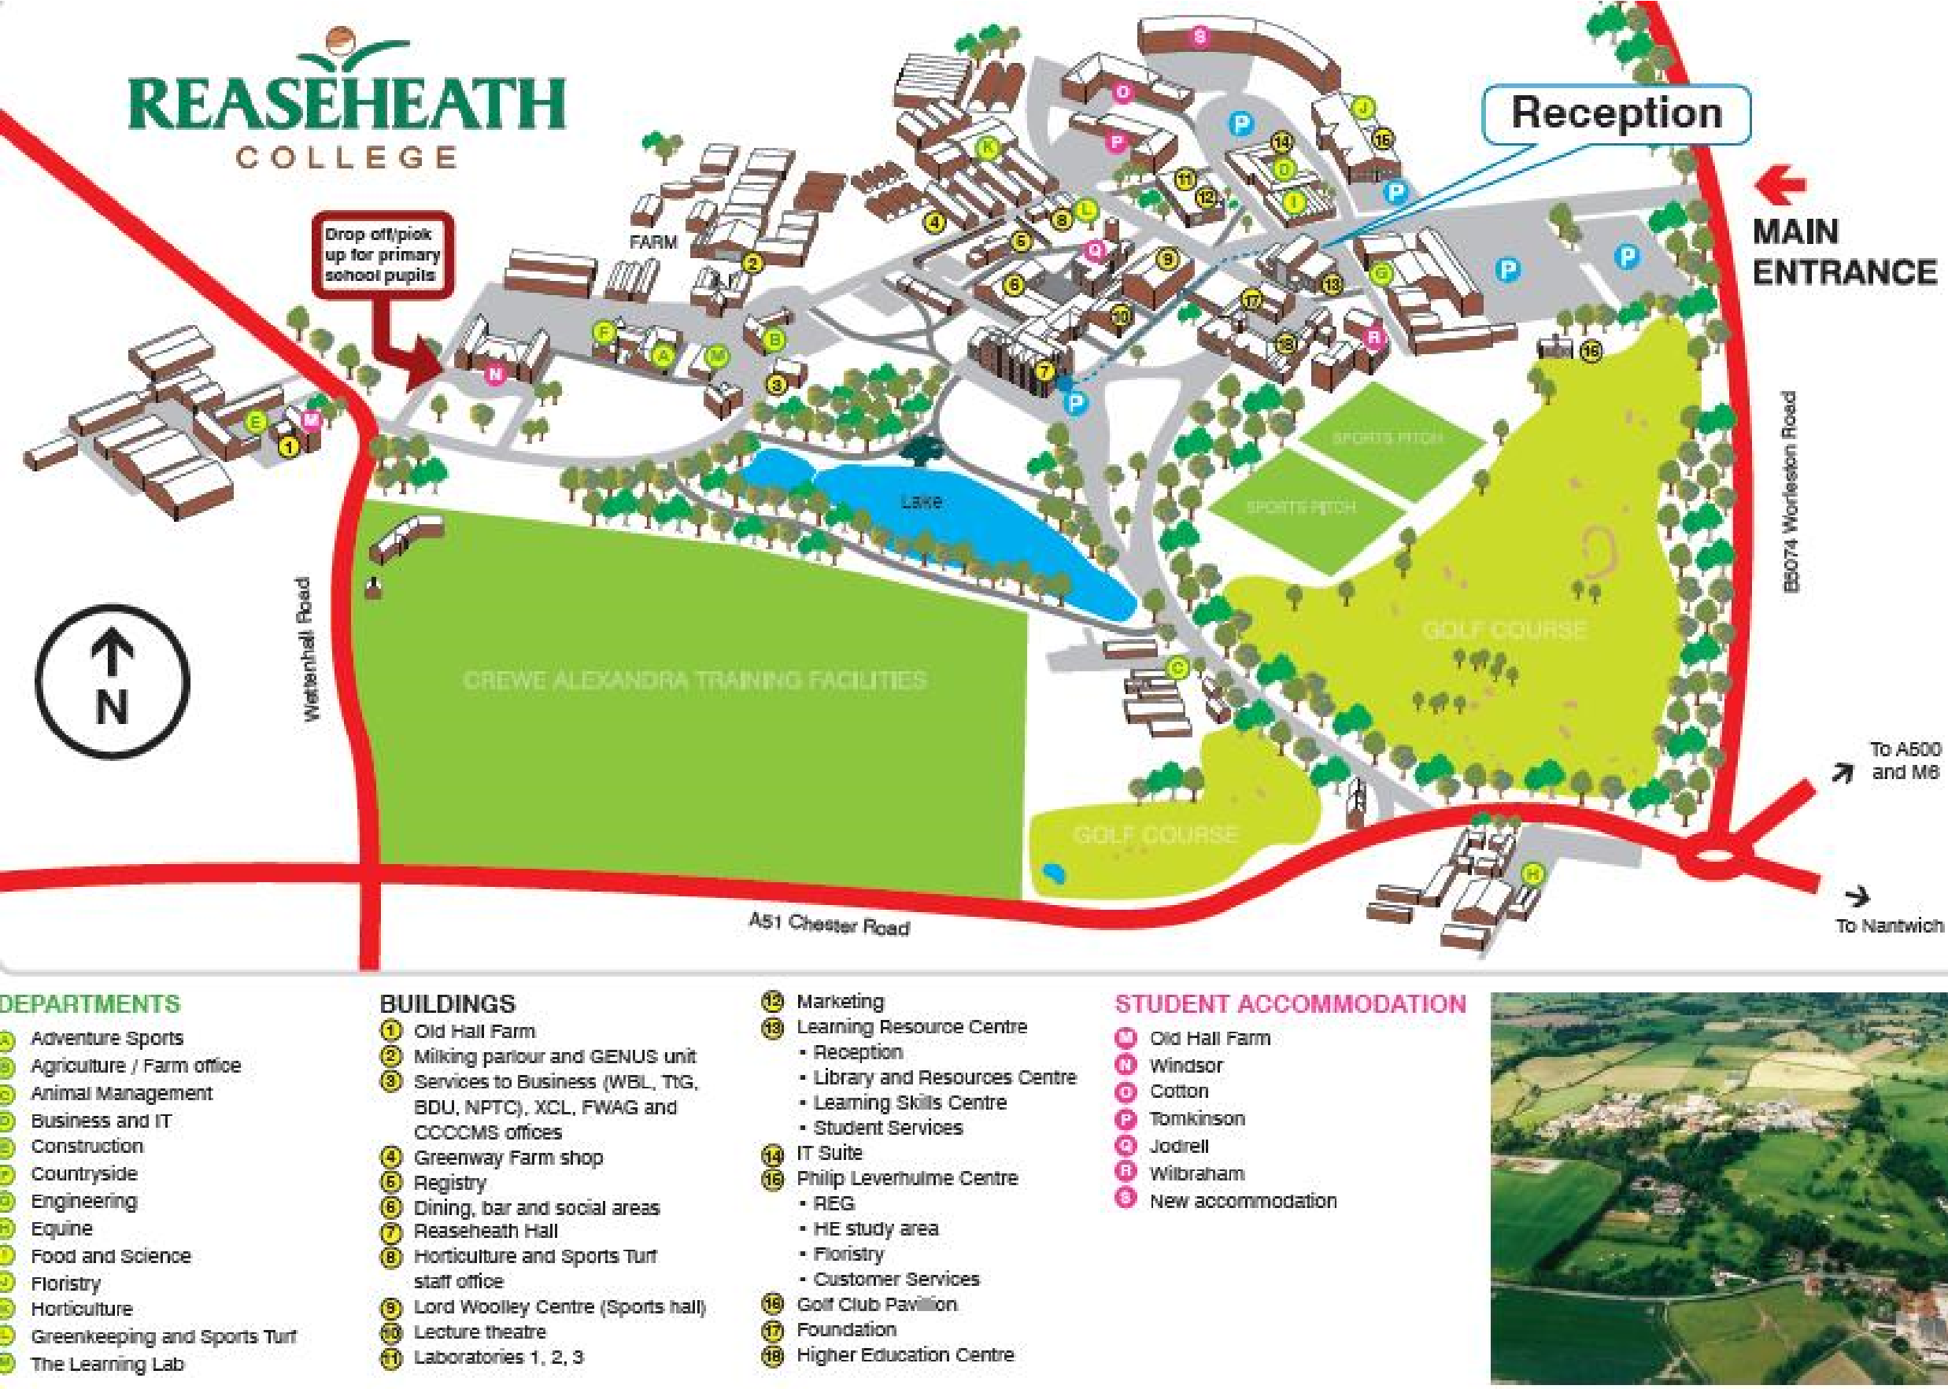

Local Amenities

Post Office
Post Office
Address: 32 Pepper Street, Nantwich, CW5 5FH (1.3 miles / 26 minutes’ walk)

Supermarket
Sainsburys Local
Address: Middlewich Road, Nantwich, Cheshire, Nantwich CW5 6PH – 1.2 miles (22 minutes’ walk)

ATM
Sainsburys Local
Address: Middlewich Road, Nantwich, Cheshire, Nantwich CW5 6PH – 1.2 miles (22 minutes’ walk)

Chemist
Lloyds Pharmacy in Sainsburys
Address: Middlewich Road, Nantwich, Cheshire, Nantwich CW5 6PH – 1.2 miles (22 minutes’ walk)

Hospital
Leighton Hospital
Address: Middlewich road, Crewe, Cheshire, CW1 4HJ (4.5 miles / 10 minutes’ drive)

Doctors
Nantwich Health Centre
Address: Church View Primary Care Centre, Beam Street, Nantwich, Cheshire, CW5 5NX (1.4 miles / 27 minutes’ walk)
*N.B. If a student is ill and requires a doctor, then a group leader and a UKLC staff member will take the student to the NHS medical centre at Nantwich Heath Centre. The student will be required to fill out a temporary patient form and will be seen on the same day.*

Dentist
Riverside Dental Practice, 1 Welsh Row, Nantwich CW5 5ED (1.4 miles / 28 minutes’ walk)

Bus Stops
Located at Cemetery corner on Middlewich Road, just under a mile away. There are frequent buses that run into the centre of Nantwich and Crewe.

Train Stations
Nantwich Railway Station
Address: Pillory Street, Nantwich, CW5 5SS (1.7 miles / 34 minutes’ walk) Frequent trains to Manchester and Shrewsbury.

Crewe Railway Station
Address: Nantwich Road, Crewe, Cheshire, CW2 6HR (4.8 miles / 15 minutes by car) Frequent trains to London, Birmingham, Manchester, Chester and Liverpool.

Taxi Companies
Haightons 01270 624574
Dabbers Private Hire 01270 628062
Coffee Shops
Pillory House Coffee Shop
Established in 1992, Pillory House Coffee Shop is a family run business. With ingredients delivered daily and homemade food prepared before your eyes in the open plan kitchens.
Address: 18 Pillory Street, Nantwich, Cheshire, CW5 5BD 1.5 miles (29 minutes’ walk)

Ginger and Pickles
An award-winning tearoom in Nantwich offering homemade cakes, delicious breakfasts, lunches, afternoon teas and fine teas.
Address: 3A Mill Street, Nantwich, Cheshire, CW5 5ST 1.5 miles (29 minutes’ walk)

Restaurants
Street
A casual food and drink venue, inspired by the street vendors and food trucks from around the world… eat in or take out.
Address: 35 Welsh Row, Nantwich, Cheshire, CW5 5ED
Walking distance from Reaseheath College: 1.5 miles (29 minutes’ walk)

Bench Bar Bistro
A truly unique restaurant that offers traditional afternoon tea as well as other lite bites.
Address: 35 Beam Street, Nantwich CW5 5NA
Walking distance from Reaseheath College: 1.3 miles (27 minutes’ walk)

The Leopard Nantwich
The Leopard is a traditional British Pub, providing excellent cask ales and traditional home cooked British dishes.
Address: 33 London Road, Nantwich, CW5 6LJ
Walking distance from Reaseheath College: 1.6 miles (32 minutes’ walk)

Accommodation

The College has two residential houses with single en-suite rooms. Each house has its own kitchen. The houses are called Chetwood and Platt and are accessed with a swipe card entry system. All bedding and towels are provided.

Room Allocation
We divide the students up according to their age, gender and group where possible. We take into consideration any specific requests, e.g. friends who want to share. Group Leaders will stay in the same house as their students. Room allocation is normally done on arrival. If you would like any further information about this, please contact us.

Housekeeping
Bedding is changed once a week and towels are changed twice a week. Bedrooms are deep cleaned once a week and bedrooms and bathrooms are given a daily clean and check.
There are coin operated washing machines and tumble dryers located in Platt and Chetwood houses. It costs £3.30 per wash and £1.90 per dry. Students must provide their own washing powder.

Key Loss
If any key or key card is lost during the stay, there will be a £25 fee for a replacement.

Deposits
We will ask each student for a deposit of €25/£25 on arrival. We will check their rooms before they arrive and before they leave, returning the money if everything is in order. If there is damage to the houses and nobody admits fault, we will ask everyone in the house to share the cost.

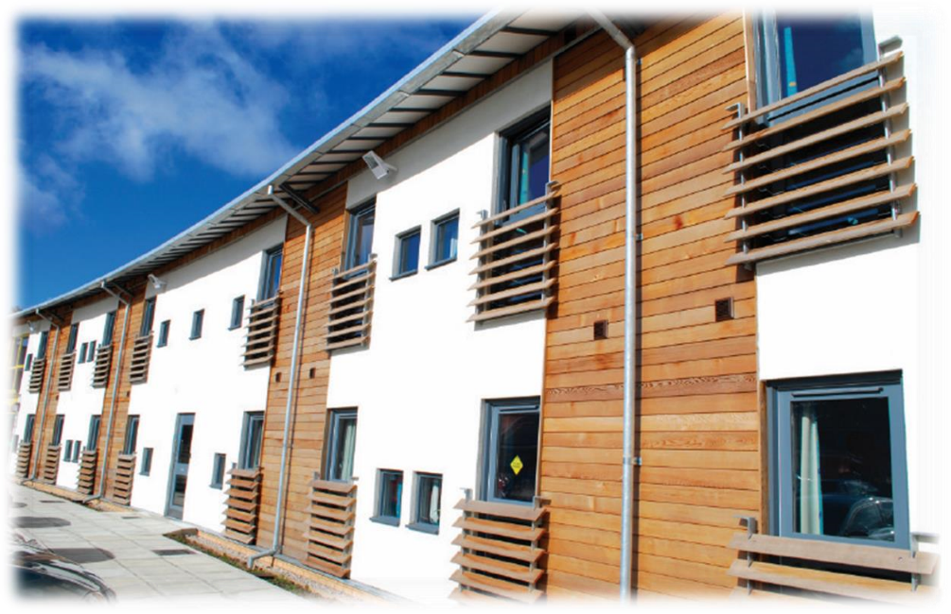

Meals

When the students are on campus, they will eat their meals in the dining hall on site. When they are out on full day excursions, they will be provided with packed lunches.
Cooked breakfast is supplied once a week.

Meal times
Breakfast: 08:00 – 09:00
Lunch: 12:30 - 13:30
Dinner: 18:00 - 19:00

If we are aware in advance, we can advise the catering staff of any dietary requirements or allergies and the canteen staff can cater to these.

*Mealtimes are subject to change

Reaseheath College, Nantwich - Sample Menu

Monday Tuesday Wednesday Thursday Friday Saturday Sunday

Breakfast | Selection of  Cereals  Bacon  Scrambled  Egg, Baked  Beans & Toast | Selection of  Cereals  Salami,  Cheese & Beef  Tomato Platter  Fresh Fruit  Croissants  Toast | Selection of  Cereals  Yoghurt  Summer  Berries  Toast & Jam  Croissants | Selection of  Cereals  Sausage  Grilled  Tomato,  Poached Egg  & Toast | Selection of  Cereals  Salami,  Cheese & Beef  Tomato Platter  Fresh Fruit  Croissants  Toast | Selection of  Cereals  Bacon  Scrambled  Egg, Baked  Beans &  Toast | Selection of  Cereals  Yoghurt  Summer  Berries  Toast & Jam  Croissants
Lunch  *(V)  Vegetarian option available | Spaghetti  Bolognese Or  Vegetarian  Spaghetti  Bolognese (V)  Garlic Bread  Salad Bar available | Assorted Meat  & Vegetarian French Bread  Pizza (V)  Fries  Baked Beans  Salad Bar available | Sausages in  Onion Gravy  Or  Vegetarian  Sausages in  Onion Gravy  (V)  Mashed Potato  2x Vegetables  Salad Bar available | Breaded Turkey  Escalope Or  Breaded  Vegetable Kiev  (V)  Roast Beef  2x Vegetables  Salad Bar available | Battered Fish  Or  Vegetable  Nuggets (V)  Chips  Garden Peas  Baked Beans  Salad Bar available | Packed  Lunch or  Weekend  Lunch (V) | Packed Lunch or Weekend  Lunch (V)
Dinner  *(V)  Vegetarian option available | Gammon &  Pineapple  Or  Homemade  Cheese &  Onion Pie (V)  Potato  Wedges  2x Vegetables  Salad Bar available | Chicken Stir  Fry  Or  Vegetable Stir  Fry (V)  Boiled Rice  Or  Noodles  Salad Bar available | Roast Beef &  Yorkshire pudding Or  Nut Roast (V)  Roast Potatoes  2x Vegetables  Salad Bar available | Beef Lasagne  Or  Vegetable  Lasagne (V)  Garlic Bread  Salad Bar available | Sausage Pasta  Bake  Or  Tomato &  Courgette  Pasta Bake (V)  2x Vegetables  Salad Bar available | Chicken  Curry  Or  Vegetable  Curry (V)  Rice  Naan Bread  Poppadum  Salad Bar available | Roast Chicken  & Stuffing Or  Macaroni  Cheese (V)  Roast  Potatoes  2x Vegetables  Salad Bar available
Pudding | Fresh Fruit  Or  Jam Doughnut | Fresh Fruit  Or  Fresh Fruit  Salad | Fresh Fruit Or  Chocolate  Topped  Doughnuts | Fresh Fruit  Or  Homemade  Flapjack | Fresh Fruit Or  Chocolate  Fudge Cake | Fresh Fruit  Or  Jam  Doughnut | Fresh Fruit  Or  Fresh Fruit  Salad

Technology

Wi-fi is available in all public areas and in most accommodation. Where there is no wi-fi there is cable access to the internet for laptop use. All campus wi-fi is password protected. We normally only give this password out to group leaders / adults. Being a college, the internet access is firewalled as per the college regulations. It is at the Group Leader’s discretion whether they give these details to their students.
Wi-fi will be switched off between 00:00 and 07:00. There is computer access on campus and you will have access to this on a timetabled basis. The Internet Café runs from 18:30 until 19:30.

Security

There is CCTV coverage on campus and 24/7 duty security/wardens. The main gate is locked at midnight.

Emergency contacts: Each student will be given a wristband when they arrive, and this will have the following emergency telephone number printed on it: 00 44 1244 567695. If you need to contact the centre in the event of an emergency please call this number and follow the options for the relevant centre, this will then put you through to the person on duty.

Certain basic guidelines are common to all centres and students. Students should:
- Never walk away alone!
- Never leave the residence without permission in the evening!
- Always make sure they have understood when and where the meeting point is whilst out on excursions!
- Always wear their identification lanyard and their UKLC wristband! *
*students found not wearing their lanyard or wristband will be fined £1

Safety

- Remember that there is a 24-hour emergency telephone number on the wristband (0044 1244 567695) and that the number for the emergency services (Ambulance/Police/Fire) in England is 999, or the single emergency number for the EU including the UK is 112 or you can call 101 to report a crime where you do not need an emergency response
- The police are there to help and protect and can be asked for assistance!
- Never respond to someone if you feel threatened, simply walk away!
- Always give your money to the UKLC management team to put in the safe and never to carry large amounts of cash around!
- Be careful crossing the road. Remember that in the UK we drive on the left!
- If you are ill or need a doctor, tell a member of UKLC staff immediately!
- Keep all windows closed when not in your bedrooms!

Insurance and valuables
Although all houses will be accessed via swipe cards, it is suggested that students try to avoid bringing very expensive items with them. If they are bringing valuables with them, it essential that they have sufficient insurance to cover any loss of damage as neither the centre nor the company can be held responsible if anything goes missing. The Centre Manager will have access to a safe if it is required.

Teaching

We know how important it is for each individual student to find their own path in language learning. We use a wide range of methods to engage and stimulate our students. This is why we have created a curriculum based on the students’ age, level and needs, structured into four different programmes:
FUN (ages 8-10)
Engaging lessons that offer a wide range of materials and activities specific for our young learners, making games into lessons and lessons into games. Available in levels A1-B1.

CONNECTION (ages 10-13)
Dynamic lessons covering a variety of topics and media, designed to engage students using tools native to the fast-paced world they are growing up in. Available in levels A1-C1.

ACTION (ages 13-16)
Lessons tailored for learners stepping into their teenage years. This programme focuses on activating students’ knowledge and competencies to balance developing a personal voice while contributing effectively to a team. Available in levels A1-C1.

PURPOSE (ages 16-18)

Lessons tailored for our students approaching adulthood, designed to kickstart their lives not only as maturing youths but also as forward-thinking global citizens. Available in levels A1-C2.

The Connection, Action, and Purpose programmes consist of three different lessons a day:

FOCUS ON LANGUAGE

These lessons aim to empower our students’ linguistic awareness and capabilities by working on all language skills (reading, writing, listening, speaking) and systems (grammar, phonology, lexis, discourse), as well as using materials relevant to exam preparation (KET, PET, FCE, CAE, TOEFL, IELTS, GESE).

FOCUS ON LEADERSHIP

This programme is designed to equip students with essential 21st-century skills, focusing on leadership development, communication and teamwork. Students build the confidence and competencies needed to grow into empowered young adults.

FOCUS ON CULTURE
These lessons combine CLIL and British culture, allowing students to use English to explore a range of disciplines, including art, literature, natural sciences, as well as the history and geography of the UK.

Placement tests
We offer classes at four levels, from elementary to advanced. Students take a placement test on their first day of classes to ensure they are placed at the correct level.

Once the tests have been marked, students won’t be told their score unless they specifically ask for it but will be placed into a class based on these results.

If students are not happy with their level, they can speak with the Course Director who will decide if it is necessary for the student to change levels.

We always try to split groups into different classes to mix nationalities, but this does depend on their levels and the numbers of students that we have on site.

We will provide all course materials including a journal and a pen.

Students are taught in class sizes up to 16.

Programme
All UKLC summer programmes include:

- 15 hours of English lessons
- Full board accommodation in residence
- Full programme of excursions, activities and evening entertainment
- 1 free leader for 15 students
- Placement test on arrival and End of Course Certificate

These are summaries of UKLC English Plus programmes** for Summer 2026 at Reaseheath College:

English Plus Multi-Activity
The “typical” summer programme consisting of a wide variety of activities and sports. Sessions are structured and are coached by specialist staff. Sessions can include tennis, basketball, volleyball, swimming, photography workshops, dance, football, and drama etc. Students are moved through two or three activities on rotation in each session.

English Plus Performing Arts*
During these sessions, students passionate about dancing, acting, or singing will immerse themselves in hands-on training designed to unleash their creative potential on any kind of stage. They will not only develop their talents but also experience the thrill of live performance, collaboration, and artistic expression.

English Plus Intensive English & Community Building*
Additional English lessons for those who really want to maximise their language learning during their stay in the UK. Based on UKLC's integral community-building approach, these additional lessons aim to help students develop an active role in the school as a thriving community, with its challenges, complexities and opportunity for collective growth. The Community Building lessons focus on how to empower students to work together to find possible solutions to these needs and issues by communicating with people on campus. Students create these projects that they are responsible for in order to improve these issues on campus.

*Students aged between 11 and 17 who are enrolled on Multi-Activity or English Plus courses will be divided by age for activities where numbers allow. Students can choose whether to enrol on the Multi-Activity or an English Plus course.
All students aged between 8 and 10 will be automatically enrolled on the multi activity programme.

**These programmes vary at each centre. A minimum of 10 students applies to each programme and each student will be asked to select a 1st and 2nd option before arrival which they will join for the duration for their stay. Students who do not choose in advance will join the standard English Plus Multi-Activity.

A typical day for students

08:00 – 09:00 | Breakfast
09:00 – 10:00 | Lesson 1
10:00 – 10:15 | Break
10:15 – 11:15 | Lesson 2
11:15 – 11:30 | Break
11:30 – 12:30 | Lesson 3
12:30 – 13:30 | Lunch
14:00 – 17:30 | Afternoon Activities
18:30 – 19:30 | Dinner
20:00 – 22:00 | Evening Activities

22:00 Bedtime

This centre runs on a ‘zig-zag’, meaning the order of lessons and multi-option activities/excursions will change
after a week. See example below.

Reaseheath College, Nantwich Sample Programme - Summer 2026
Week 1 |  | Morning | Afternoon | Evening
 | Saturday | English Test | Multi-Activity or  Chosen Programme | Film Night
 | Sunday | Manchester with Manchester City Etihad Stadium Tour |  | Oscars
 | Monday | Lessons | Nantwich Town  Orientation | Message Disco or Conversation Club
 | Tuesday | Lessons | Vlogging Workshop or Chosen Programme | Trashion Show
 | Wednesday | Lessons | Chester with Roman  Tour | Paparazzi
 | Thursday | Lessons | Multi-Activity or  Chosen Programme | Attractions or Conversation Club
 | Friday | Lessons | Multi-Activity or  Chosen Programme | Quiz Night
W  eek 2 | Saturday | Stratford Upon Avon with Shakespeare’s  House |  | Mini Olympics or Conversation Club
 | Sunday | Free Time, Activities or Optional Excursion |  | Murder Mystery
 | Monday | Chester with Boat Trip | Lessons | Red vs Blue
 | Tuesday | Vlogging Workshop or Chosen Programme | Lessons | Karaoke
 | Wednesday | Liverpool with Museum of Liverpool and Albert Dock | Lessons | Games Night or Conversation Club
 | Thursday | Multi-Activity or  Chosen Programme | Lessons | Leaving Disco
 | Friday | Departures

Please note: This is a sample programme and may be subject to change. It may also be necessary to operate a zig zag programme of morning / afternoon lessons.

Facilities
Sports facilities on site:

- Sports hall
- Grass football pitch
- Marked 3G Astro-turf football pitches
- Dance studio
- Cricket pitches
- Reaseheath Zoo

Sports available at this centre can include: football, handball, basketball, rounders, volleyball, cricket, indoor hockey, and table tennis.

Evening entertainment
The UK Language Courses staff plan fantastic activities to make sure the students enjoy their evenings. For example: discos, quizzes, fashion shows, blind date, sports tournaments etc. We ask Group Leaders to encourage students to participate as much as possible and to communicate any special ideas or requests from students.

Here are a few brief descriptions of just some of our activities for students to join in on:

Around the World
Consists of a number of different stations based on activities from different countries. One staff member will be placed at each activity station. They will each represent a country and have to create an activity related to that country (for example: New Zealand – The Haka). Students will be divided into groups and given a time for each station. Students will visit each station.

Oscars Night
Involves students watching a number of scenes from selected films. They will have the chance to re-enact a famous selected scene. Creating their own script, which must be in English and costumes (out of various given equipment). Scenes will be shown on a big screen for everyone to watch. Awards will be given by UKLC staff for the best reproduction.

Speed Dating
Enables students from mixed nationalities to socialise and get to know each other whilst improving their spoken English. Students will have a short period of time to have a conversation on their interests, hobbies etc. Once the given time finishes they will move to another student and begin the same process again.

Talent Show
Gives students the opportunity to perform talents such as singing, dancing and acting in front of the whole centre! Sign-up sheets will be available in the centre a few days before the event. There will be judges who will score the performances and give positive feedback to each student who performs on the evening.

We look forward to welcoming you to Reaseheath College in summer 2026!


